Step 1: Login to your account

Step 2: Click on Compliance Policy Training

Step 3: Go through the training material tab by tab

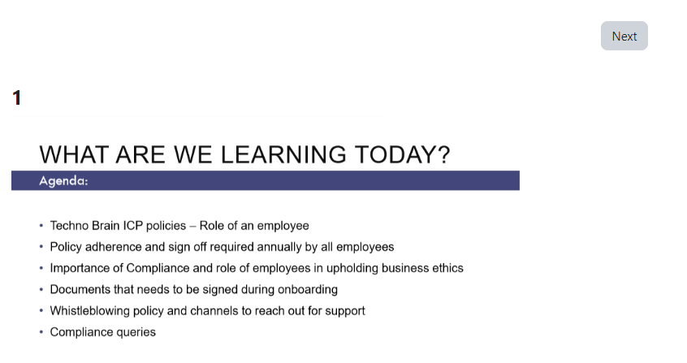

Step 4: When done with the training you can attempt to take the quiz

Step 5: On submission of answers to all questions you can submit